UNIVERSITY OF NOVI SAD
MEDICAL FACULTY NOVI SAD
DEPARTMENT OF HYGIENE

Integrated academic studies in Medicine
Results for the exam HYGIENE
January 2022.

Results of the Hygiene exam held on February 3rd, 2022. in the AMPHITHETER A2 of the Faculty of Medicine is shown in the table.

Enrollment of Hygiene grades will be held on Institute of Public health, on Wednesday, February 9, 2022 at 11 am.

The student representative of the year should bring the indexes of students who are satisfied with the grade at the Institute of Public Health of Vojvodina and waits for the teacher at the main entrance.

If someone cannot submit the index at the specified time, must send an e-mail to natasa.dragic@mf.uns.ac.rs, in order to agree on another date for entering the grade.

Students who have passed the exam, but they are not satisfied with the grade and don't want it to be entered in the index, they should inform the professor by e-mail: natasa.dragic@mf.uns.ac.rs by February 8, 2022 until 1 pm.

Name and Surname | Grade
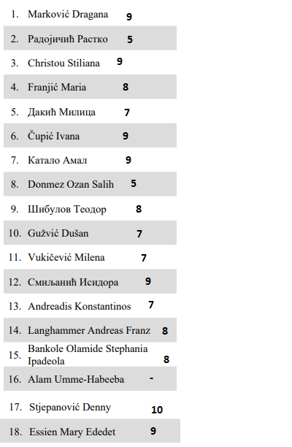

Department of Hygiene
Assistant professor
Nataša Dragić

