UNIVERSITY OF NOVI SAD
MEDICAL FACULTY NOVI SAD
DEPARTMENT OF HYGIENE

BASIC MEDICAL STUDIES IN ENGLISH
DENTISTRY

Schedule for the exam in PUBLIC HEALTH

Јune 2019
12.06.

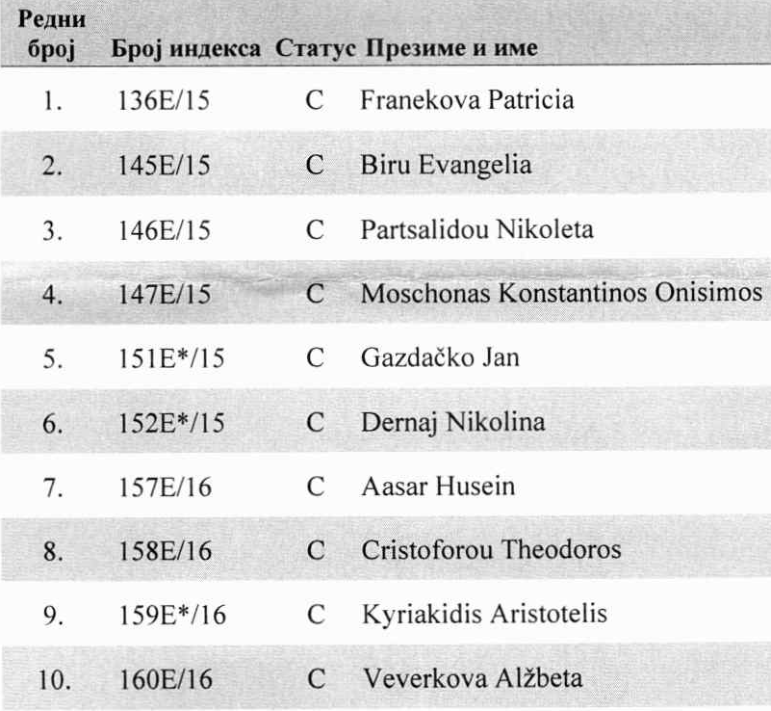
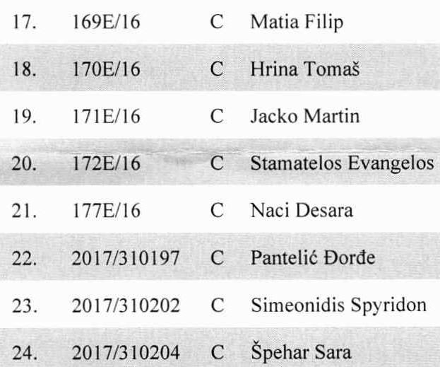
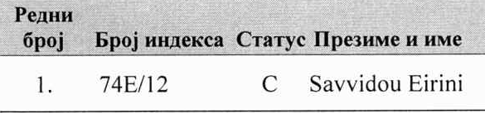

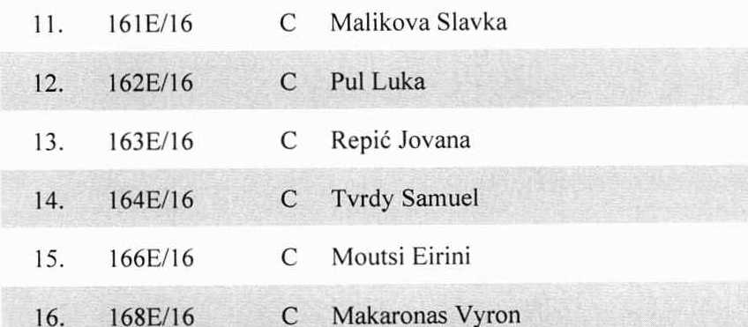

It is necessary to confirm the exam at least 24 hours before the date of schedule. In this period, there is NO changing of term of exam.
The exam can be confirmed by phone (021 / 4897-879), e-mail (katedra_higijena@izjzv.org.rs), or in person in room 43 on the first floor of the Institute of Public Health of Vojvodina.
Pre-exam consultations are held on Wednesdays from 12-14 hours, between exam periods.

Students gather on the second floor of the Institute of Public Health of Vojvodina, where they will wait for an assistant. The exam starts at 8.00 a.m.

Department reserves the right to objective reasons change the place of the exam and on how students will be notified at least 48 hours in advance on the website of the Department of Hygiene.
HEAD OF THE DEPARTMENT OF HYGIENE
ASSISTANT PROFESSOR JELENA BJELANOVIĆ

