UNIVERSITY OF NOVI SAD
MEDICAL FACULTY NOVI SAD
DEPARTMENT OF HYGIENE

Integrated academic studies in Medicine
Schedule for the exam HYGIENE
January 2022.

In the January exam period, the exam will be taken in the form of a test.
The exam will be held on 03.02.2022, in the amphitheater A2 at the Faculty of Medicine, at 13.30h.
It is necessary to bring the completed exam application.

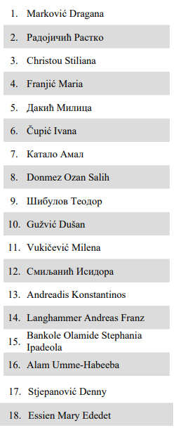

HEAD OF THE DEPARTMENT OF HYGIENE
Associate professor Jelena Bjelanović

